IOT Assignment By:

SADIQ BASHA .M

SHANMUGAVEL.S

VIGNESH.T

THISPHIYAN.T

RAJ KAMAL.M

1. Alarm should give one sound when there is motion near PIR sensor. Circuit diagram:

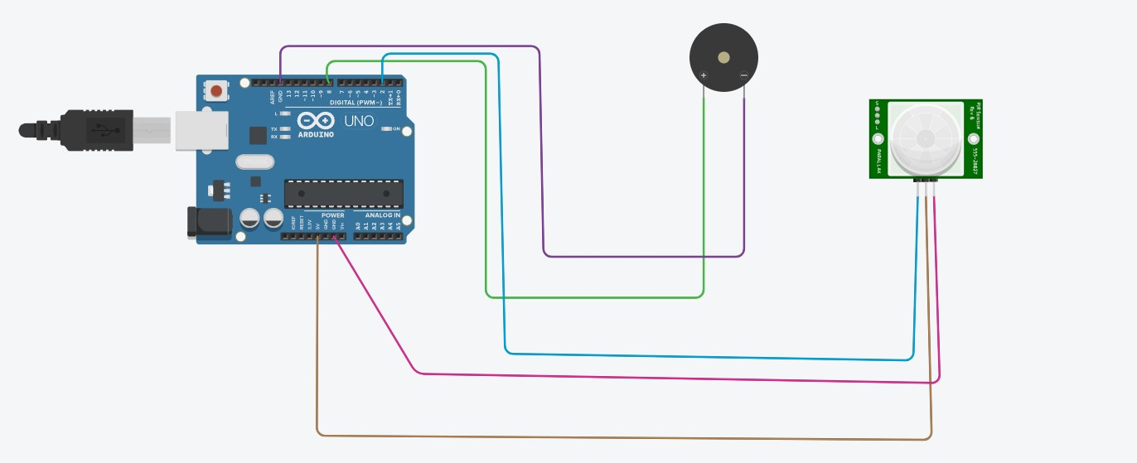

Coding:

void setup()

{

Serial.begin(9600); pinMode(8,OUTPUT); pinMode(2,INPUT);

} void loop() { for(int freq=0; freq<=30000;freq++)

{ tone(8,freq); delay(1000); noTone(8); delay(500); int motion=digitalRead(2); Serial.print("Position is:");

Serial.println(motion);

}

}

Output:

Position is:0

Position is:0

Position is:0

Position is:1

Position is:1

Position is:1

Position is:0

Position is:0

Position is:1

Position is:1

2.Alarm should give different sound when temperature is above 60 degree.

Circuit diagram:

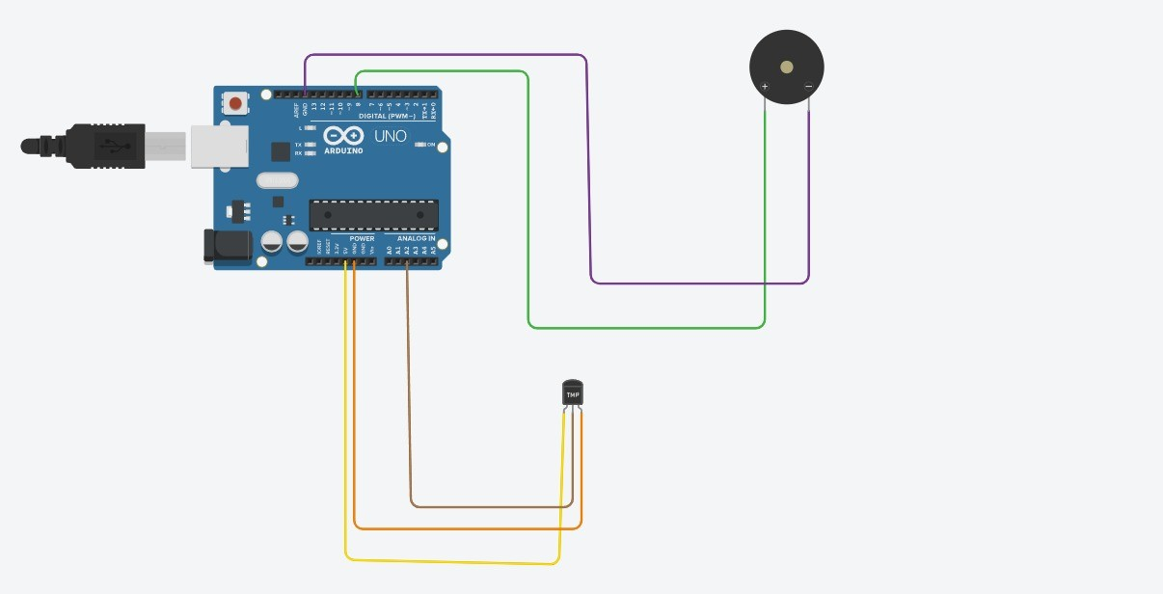

Coding: void setup()

{

Serial.begin(9600); pinMode(8,OUTPUT);

} void loop() { for(int freq=0; freq<=30000;freq++)

{ tone(8,freq); delay(1000); noTone(8); delay(500); double data=analogRead(A2); double n=data/1024;

Serial.print("Converted to analog data:");

Serial.println(n); double volt=n\*5;

Serial.print("Voltage data"); Serial.print(volt); double off=volt-0.5;

Serial.print("Serial off set data:"); int sound=freq; sound=0.034\*freq; if(sound>=60)

{

Serial.print("The Sound is High");

} else

{

Serial.println("The Sound is Low");

}

}

}

Output: data:0.15

Voltage data0.75Serial off set data:The

Sound is Low

Converted to analog data:0.15

Voltage data0.75Serial off set data:The

Sound is Low

Converted to analog data:0.15

Voltage data0.75Serial off set data:The

Sound is Low

Converted to analog data:0.15

Voltage data0.75Serial off set data:The

Sound is Low

Converted to analog data:0.15

Voltage data0.75Serial off set data:The

Sound is Low

Converted to analog data:0.15

Voltage data0.75Serial off set data:The

Sound is Low

Converted to analog data:0.15

Voltage data0.75Serial off set data:The

Sound is Low

Converted to analog data:0.15

Voltage data0.75Serial off set data:The

Sound is Low

Converted to analog data:0.15